6. Connected Solution Architecture
12.1 Deployment Sequence
DOCAYA
Enterprise Electronic Document Management System
Consolidated Functional & Technical Specification
Revised from the v1.2 technical specification against the v1.3 functional and business design baseline
Document attribute | Value
Version | 1.3 — Consolidated Build Baseline
Source baseline | Docaya Functional & Business Design v1.3 (revised lifecycle, Ask Docaya, thumbnails, POC classification)
Supersedes | Docaya Functional & Technical Specification v1.2 (and v1.1)
Platform | Microsoft Azure · Microsoft 365 · SharePoint Online · Entra ID · UAE PASS
Status | Draft for Review — build baseline subject to POC outcomes (Section 14)
Classification | OFFICIAL – Internal
Date | 13 September 2026

Baseline rule Where this specification conflicts with the v1.3 Functional & Business Design, v1.3 governs. Sections superseded by v1.3 — bulk/5 GB capture, the exclusion of embeddings, and the earlier module naming — have been replaced in place. Items requiring technical proof before build are consolidated in Section 14, Proof of Concept (POC) Plan.

Table of Contents
Table of Contents 2
Document Control 3
Reconciliation and Deletion Register 3
1. Introduction 4
1.1 Purpose 4
1.2 Scope 4
1.3 Authoritative Principles 4
2. Business Objectives, Actors and Access 4
2.1 Personas and Default Review Chain 4
3. Capability Catalogue 5
4. Authoritative End-to-End Lifecycle 7
4.1 Main Lifecycle 7
4.2 State Model 8
State transitions 8
5. Functional Requirements 9
5.1 M1–M2 Capture, Registration and Classification 9
5.2 M3 Workflow, Review and SLA 9
Default configurable chain 9
5.3 M4–M7 Publication, Staging, Extraction and Notifications 10
5.4 M8–M12 Correspondence, Records, Search, Identity and Access 10
5.5 M13–M16 Administration, Modification, Analytics and Audit 10
5.6 M10 Ask Docaya — Retrieval and Answering 11
6. Connected Solution Architecture 13
6.1 Connected request and publication path 14
7. Application Architecture and VS Code Structure 14
7.1 Clean Architecture Dependency Rules 14
8. Data Architecture 14
8.1 Core Entities 14
9. Integration and API Specification 15
9.1 SharePoint / Graph 15
9.2 Search Publication 15
9.3 Representative APIs 15
9.4 Domain Events 16
10. Security, Compliance and Operations 17
11. Non-Functional Requirements 17
12. Packaging, Deployment and Environments 17
12.1 Deployment Sequence 17
13. Testing and Acceptance 18
13.1 UAT Exit Criteria 18
14. Proof of Concept (POC) Plan 18
14.1 POC Priority by Module 18
14.2 POC Workstreams, Method and Success Criteria 19
14.3 POC Exit Criteria and Decisions Unlocked 20
15. Roadmap, Decisions and Open Items 20
15.1 Accepted Decisions 20
15.2 Open Items Before Baseline Freeze 21

Document Control
Version | Status | Summary
1.1 | Superseded | Earlier technical baseline.
1.2 | Superseded | Reconciled to the v1.2 functional design; first complete functional, application, data, integration, security, deployment and test baseline.
1.3 | Draft for review | Reconciled to the v1.3 functional design: single-file 100 MB capture, document thumbnails, Department Tag and Document Publishing Scope, Ask Docaya (M10) with post-approval embeddings and cited answering, A New Revision (M14), refreshed lifecycle and architecture diagrams, and a new Proof of Concept plan (Section 14).

Reconciliation and Deletion Register
Superseded content | Action | v1.3-aligned replacement
AI/OCR classification suggestions during upload | Deleted | Upload-time extraction remains limited to basic readable text, technical metadata, preview and thumbnail; classification stays manual (unchanged in v1.3).
v1.2 exclusion of embeddings, vectors and AI answering | Reversed | v1.3 introduces Ask Docaya (M10): document embeddings and cited natural-language answering created only after final approval and publication. Nothing in staging is indexed, embedded or answerable.
Bulk drag-and-drop and 5 GB upload limit | Replaced | One file per registration, maximum 100 MB, resumable and chunked, validated in browser and re-validated server-side.
OBO SharePoint access as the signed-in user | Replaced | Docaya authorizes the user; a governed service identity performs SharePoint operations (unchanged in v1.3).
Public documents auto-approved | Deleted | Final configured review approval is mandatory before publication.
"Search & Discovery" (M10) and "Existing Document Modification" (M14) | Renamed | M10 is Ask Docaya — Search, Discovery & AI Answering; M14 is A New Revision, invoked on screen as "Submit a New Revision". The words modification, change request and amendment are not used on screen.
Registration metadata without tagging or preview | Added | Document Thumbnail, Department Tag, Document Publishing Scope and Standard are captured at registration and drive navigation, visibility and notification reach.
Lifecycle notifications only | Extended | Adds the first-login onboarding reading list and the department-wide broadcast whenever a departmental document is published.
Disconnected architecture images and no proving plan | Replaced | Connected lifecycle, review-chain, publication-path and Ask Docaya flow diagrams in this document, plus the module-level POC classification and plan in Section 14.

1. Introduction

1.1 Purpose
This specification is the authoritative design, build, test and deployment baseline for Docaya. It translates the v1.3 Functional & Business Design into testable functional requirements, workflows, connected architecture, data and API contracts, security controls, project structure, deployment packaging, acceptance criteria and the proof-of-concept work required before build commits.

1.2 Scope
In scope | Out of scope
Sixteen modules M1–M16; governed staging-first lifecycle; single-file 100 MB capture with thumbnail; manual classification with Department Tag, Document Publishing Scope and Standard; configurable review chain; change-request SLA; Ask Docaya permission-trimmed search and post-approval AI answering; A New Revision; analytics; audit; Azure/M365 integration; packaging, deployment and the POC plan. | Legacy migration; physical records beyond scan capture; any AI classification, metadata or approver recommendation at upload, registration or classification; indexing or answering over unapproved content; file-format conversion; bulk multi-file upload; commercial licensing and final infrastructure sizing.

1.3 Authoritative Principles
- SharePoint Online is the published content system of record.
- Azure SQL is authoritative for registry, metadata, workflow, SLA and audit.
- The unchanged original file stays in staging until final approval; one file per registration, maximum 100 MB.
- Business classification is entered manually by the Editor; no AI suggestion at loading, registration or classification.
- Docaya manages user authorization; SharePoint operations use a governed service identity.
- Indexing, embedding and AI answering apply only to approved, published content and are always permission-trimmed and cited.
- Every approved version carries its own document thumbnail; earlier thumbnails are retained with their version.
- Configuration controls document types, stages, routes, calendars and taxonomy without code.
- Components marked POC – Critical in Section 14 are proven before the corresponding build commits.

2. Business Objectives, Actors and Access
Ref | Objective | Outcome
O1 | One governed repository | One current approved version.
O2 | Controlled lifecycle | No unclassified or unapproved publication.
O3 | Accountable review | Complete decision and stage history.
O4 | Fast secure retrieval | Permission-trimmed results in seconds.
O5 | Trusted ecosystem | UAE PASS, Entra, Azure and Microsoft 365.
O6 | Bilingual service | Arabic, English and RTL.
O7 | Governed change control | 12/30-working-day targets and bottleneck visibility.

2.1 Personas and Default Review Chain
Role | Capabilities
Editor / Change Requester | Capture, register, classify, submit, correct and resubmit.
Document Owner / Approver | Stage-2 substantive review.
Assurance | Stage-3 quality/compliance review and target-extension authority.
Authoriser | Configured final sign-off and publication gate.
Records & Compliance Officer | Retention, legal hold, disposition and audit.
Administrator | Schemas, routes, stages, SLA, notifications and taxonomy.
Consumer / Viewer | Permission-trimmed browse, search, preview and download.

3. Capability Catalogue
The catalogue below is the master module list for build. The POC column records where technical or compliance risk must be proven before the corresponding build commits; the full method, success criteria and sequence are in Section 14. Critical means it must be proven first, Recommended means a proven pattern that should still be validated at Client scale, and Not required means standard configuration with no novel risk.  Module | Capability | Key v1.3 rule | POC (Section 14)
M1 | Capture & Registration | One native file per registration, maximum 100 MB, to staging; tracking number; limited extraction; thumbnail captured. | Critical
M2 | Classification & Metadata | Manual class, sensitivity, department, Standard, Department Tag, Document Publishing Scope, access and route. | Critical
M3 | Workflow & Approval | Configurable 3–4 stages, thread, working-day SLA, extension and correction point. | Recommended
M4 | Promotion & Publishing | Final approval only; native file to SharePoint; idempotent write-back. | Critical
M5 | Staging Lifecycle | Retain/purge/move and replay failed promotion. | Not required
M6 | Upload Text Extraction & Search Data | Basic bilingual source text/preview at upload; embedding batch only after publication. | Critical
M7 | Notification Center | Lifecycle, at-risk, overdue, expiry, security, department-wide publication broadcast and first-login reading list. | Recommended
M8 | Correspondence Management | Incoming/outgoing references, threading and actions on the core pipeline. | Not required
M9 | Records & Retention | Schedules, disposition, declaration, legal hold and UAE residency. | Recommended
M10 | Ask Docaya — Search, Discovery & AI Answering | One box: Quick Search, Ask (AI Search) and Browse over approved content only, with thumbnails and citations. | Critical — highest priority
M11 | Identity & SharePoint | UAE PASS/Entra SSO; governed service identity for all content operations. | Critical
M12 | Access Control | RBAC + ABAC, deny by default, applied to answers, results and thumbnails. | Critical
M13 | Admin Center | No-code configuration, including the approval-level designer and navigation taxonomy. | Not required
M14 | A New Revision | "Submit a New Revision" against the approved version; comparison, fresh thumbnail, next native version. | Recommended
M15 | Analytics | Embedded Power BI operational, change-request and compliance reports with row-level security. | Recommended
M16 | Audit & Compliance | Hash-chained chronological history, version thread and IA/PDPL evidence export. | Recommended

4. Authoritative End-to-End Lifecycle

4.1 Main Lifecycle
1 Capture  Native file to staging  → | 2 Register  Technical + user fields  → | 3 Classify  Manual metadata  → | 4 Submit  Resolve chain + SLA  → | 5 Review  Owner → Assurance  → | 6 Authorise  Final decision  → | 7 Promote  SharePoint v1.0  → | 8 Reconcile  Staging policy  → | 9 Index & Govern  Ask Docaya, retain, audit

Step | Actor | Behaviour | State / location
1 Capture | Editor | One file per registration, maximum 100 MB; validate extension and signature; chunked resumable upload; unchanged file; SHA-256; malware and DLP; tracking number; document thumbnail captured. | PendingRegistration · staging
2 Register | Editor / System | Pre-fill technical attributes; enter title, description, keywords and references. | Draft · staging
3 Classify | Editor | Manually select class, sensitivity, department, priority, Standard, Department Tag, Document Publishing Scope, access and flow. No AI suggestion is offered. | Classified · staging
4 Submit | Editor | Validate schema; resolve target library and review stages; start the working-day SLA. | PendingApproval · staging
5 Review | Configured reviewers | Approve, return with mandatory threaded comment, reassign or extend if authorised. | InReview / Returned
6 Final approval | Authoriser | Permit publication only after all required stages are complete. | Approved · staging
7 Promote | System | Graph uploads the same file under the governed service identity; write back item ID, URL and version. | Published · SharePoint
8 Reconcile | System | Purge, retain or move staging content; replay a failed promotion. | Reconciled
9 Index & govern | All / System | Build the Document Index Record for the published version — metadata, approved source text, embedding and thumbnail reference — then serve Ask Docaya, versions, retention, analytics and audit. | Continuous · published only
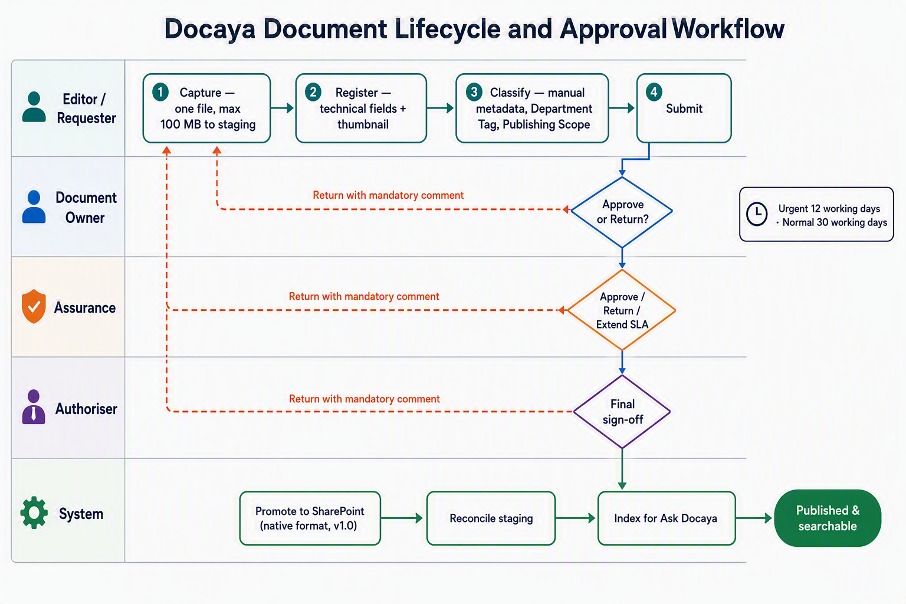
Figure 1 — Docaya document lifecycle and approval workflow: staging-first capture, manual classification, the configurable three or four-stage review chain with mandatory-comment return paths, approval-driven promotion in the native file format, and post-publication indexing for Ask Docaya.
Non-negotiable controls No AI classification, metadata or approver suggestion at loading, registration or classification. No file-format conversion. No publication before final approval. No indexing, embedding, answering or thumbnail exposure for unapproved content. No result, answer or preview outside the user's effective permission.

4.2 State Model

State transitions
Draft  Registration  → | Classified  Metadata complete  → | Pending  Review started  → | Returned  Correction  → | Approved  Final sign-off  → | Published  SharePoint  → | Superseded  New version  → | Archived  Disposition

5. Functional Requirements

5.1 M1–M2 Capture, Registration and Classification
ID | Requirement | Priority | Acceptance criterion
FR-CAP-01 | The system MUST accept one approved file per registration by drag-and-drop or browse; multi-file or bulk upload MUST be rejected. | Must | A second file is blocked with a clear message.
FR-CAP-02 | The system MUST support resumable chunked upload up to 100 MB, enforced in the browser and re-validated server-side. | Must | Interrupted upload resumes; an oversized file is rejected.
FR-CAP-03 | The original file MUST be stored unchanged in the configured staging store. | Must | Staged hash matches the local source.
FR-CAP-04 | The system MUST issue DOC-YYYY-NNNNNN and create the registry row immediately. | Must | A unique number and first audit record exist.
FR-CAP-05 | The system MUST compute SHA-256 and complete malware and DLP checks before submission. | Must | A failed scan blocks progression.
FR-CAP-06 | Only technical metadata, source text and preview MAY be extracted automatically. | Must | No business classification or recommendation is produced.
FR-CAP-07 | The Editor MUST manually select class, sensitivity, department, priority, Standard, access and approval flow. | Must | Required fields block submission until complete.
FR-CAP-08 | Metadata MUST validate against the active type schema. | Must | Field errors identify invalid input.
FR-CAP-09 | Routing rules MUST resolve the target SharePoint library and review chain. | Must | The resolved route is stored and previewed.
FR-CAP-10 | A document thumbnail (cover or first page) MUST be generated automatically at registration and again on each approved revision, and referenced against the registry row for that version. | Must | Each version keeps its own thumbnail; suppressed classes fall back to a neutral icon.
FR-CAP-11 | The Editor MUST apply a Department Tag (owning plus related departments) and a Document Publishing Scope (Departmental, Cross-Departmental, Organisation-wide, Public) at registration. | Must | Tags drive navigation, visibility and notification reach on publication.

5.2 M3 Workflow, Review and SLA

Default configurable chain
Stage 1  Editor submits  → | Stage 2  Owner reviews  → | Stage 3  Assurance checks  → | Stage 4  Authoriser signs  → | Publish  Final gate

ID | Requirement | Priority | Acceptance criterion
FR-WF-01 | The system MUST support configurable 3- or 4-stage named chains by type/department. | Must | Configured stages are enforced.
FR-WF-02 | Stages MUST support sequential, parallel/quorum and conditional routing. | Must | Test routes match configuration.
FR-WF-03 | Return MUST require a threaded comment and correction point. | Must | Return cannot complete without both.
FR-WF-04 | A resubmission MUST resume at the configured correction point. | Must | History and stage sequence remain intact.
FR-WF-05 | Urgent and Normal requests MUST default to 12/30 working-day targets. | Must | Configured weekends/holidays are excluded.
FR-WF-06 | At-risk, overdue, stage duration and remaining days MUST be visible. | Must | Timeline and reports reconcile.
FR-WF-07 | Extensions MUST retain original/current target, authorised actor and reason. | Must | Original target is never overwritten.
FR-WF-08 | Final approval MUST emit one idempotent promotion command. | Must | Retry produces no duplicate item.

5.3 M4–M7 Publication, Staging, Extraction and Notifications
ID | Requirement | Priority | Acceptance criterion
FR-PUB-01 | Promotion MUST publish the unchanged original file through Microsoft Graph and the governed service identity. | Must | Published and staged hashes match.
FR-PUB-02 | SharePoint site, drive and item IDs, URL and version MUST be written back. | Must | The registry opens the correct record.
FR-PUB-03 | Failed promotion MUST retain the file and support idempotent replay. | Must | Replay succeeds exactly once.
FR-PUB-04 | Staging cleanup MUST follow a configurable purge, retain or move policy. | Must | The action is auditable.
FR-PUB-05 | Live search MUST contain only published metadata and approved source text. | Must | An unpublished test file is absent.
FR-PUB-06 | Embeddings and the Document Index Record MUST be produced only after final approval and publication, never at upload, registration or classification. | Must | No vector or index entry exists for a staged item.
FR-PUB-07 | Notifications MUST cover assignments, decisions, returns, publication, at-risk and overdue, extensions, expiry and security. | Must | Configured channels receive messages.
FR-PUB-08 | Security notifications MUST be mandatory. | Must | The user cannot disable them.
FR-PUB-09 | Publication MUST raise a notification to the audience implied by the Department Tag and Document Publishing Scope, de-duplicated and subject to quiet hours. | Must | Every entitled recipient receives exactly one alert.
FR-PUB-10 | A new joiner MUST receive the Admin-configured onboarding reading list at first sign-in, with acknowledgement tracked. | Must | The list reflects the user's department and permissions.

5.4 M8–M12 Correspondence, Records, Search, Identity and Access
ID | Requirement | Priority | Acceptance criterion
FR-CORE-01 | Correspondence MUST support references, sender and recipient, due date, bilingual content and reply threading. | Must | The full chain is retrievable by reference.
FR-CORE-02 | Retention MUST support time and event triggers, disposition and legal-hold override. | Must | Hold blocks deletion.
FR-CORE-03 | Ask Docaya MUST offer one entry point covering Quick Search, Ask (AI Search) and Browse by Department or Standard, with faceted filters and source-text match (detailed in 5.6). | Must | Filtered results match authorised records.
FR-CORE-04 | Listing results MUST provide one-click preview, download and open-folder actions. | Must | Each permitted action succeeds.
FR-CORE-05 | UAE PASS MUST federate to Entra ID with MFA and Conditional Access. | Must | Policy-compliant sign-in succeeds.
FR-CORE-06 | SharePoint operations MUST use the governed service identity after Docaya authorization. | Must | No on-behalf-of token is used.
FR-CORE-07 | Every access decision MUST be deny-by-default and audited. | Must | Policy and audit evidence agree.

5.5 M13–M16 Administration, Modification, Analytics and Audit
ID | Requirement | Priority | Acceptance criterion
FR-GOV-01 | Admins MUST configure schemas, vocabularies, routes, stages, SLA calendars, warnings and taxonomy without code. | Must | Published configuration affects new requests.
FR-GOV-02 | A New Revision MUST start against the current approved version without overwriting it. | Must | The approved version remains readable.
FR-GOV-03 | Final approval of a New Revision MUST create the next SharePoint native version, capture a fresh thumbnail and refresh the Document Index Record. | Must | Version, thumbnail, index and timeline link correctly; the prior version stays readable.
FR-GOV-04 | Embedded Power BI MUST present permission-trimmed metadata, workflow, SLA, change-request, document-control and compliance reports. | Must | Row-level security matches Docaya access.
FR-GOV-05 | Every state, field, decision, comment, extension, access and version event MUST enter the hash-chained audit. | Must | Alteration breaks chain verification.

5.6 M10 Ask Docaya — Retrieval and Answering
Ask Docaya is a single box and a single result surface. The user types a keyword, a tracking number or a full question in Arabic or English and the system decides how to answer it. Two sources sit behind it: the registry metadata in Azure SQL and the document embedding produced only after final approval and publication. Steps are referenced as AD-1 to AD-9 in design, test and training material.
AD-1 Ask  One box, AR/EN  → | AD-2 Interpret  Language, intent, filters  → | AD-3 Authorise  RBAC + ABAC keys  → | AD-4 Metadata  Azure SQL registry  → | AD-5 Semantic  Approved embeddings  → | AD-6 Rank  Hybrid merge  → | AD-7 Compose  Grounded, cited  → | AD-8 Present  Answer Card + thumbnails  → | AD-9 Log  Audit + analytics

ID | Requirement | Priority | Acceptance criterion
FR-ASK-01 | One input MUST accept a keyword, tracking number or natural-language question in Arabic or English and route it without the user choosing a mode. | Must | Each input type returns the expected surface.
FR-ASK-02 | Effective permission MUST be resolved before retrieval and carried as security keys on every query. | Must | Unauthorised documents never enter the candidate set.
FR-ASK-03 | Only published or otherwise approved versions MUST be eligible; draft, classified, pending, returned and rejected items MUST be excluded. | Must | Staged test file is absent from results and answers.
FR-ASK-04 | Metadata and semantic results MUST be merged and ranked into one result set, with the current approved version returned first. | Must | Earlier versions appear only in document history.
FR-ASK-05 | Every statement in an answer MUST carry a citation to document, tracking number and version; where the approved estate has no answer the system MUST say so rather than infer. | Must | No uncited statement is produced in test sets.
FR-ASK-06 | Result rows and the Answer Card MUST show the thumbnail of the relevant version, trimmed and redaction-aware exactly as the document is. | Must | Suppressed classes render a neutral icon.
FR-ASK-07 | Cross-language retrieval MUST be supported, so an Arabic question can return English sources and the reverse, with the answer in the language asked. | Should | Bilingual test pairs return the same source document.
FR-ASK-08 | Indexing, embedding and answering MUST execute only within the approved UAE Azure regions, and every query, filter, result and open MUST be audited. | Must | Traces show no out-of-region call; audit reconciles with analytics.

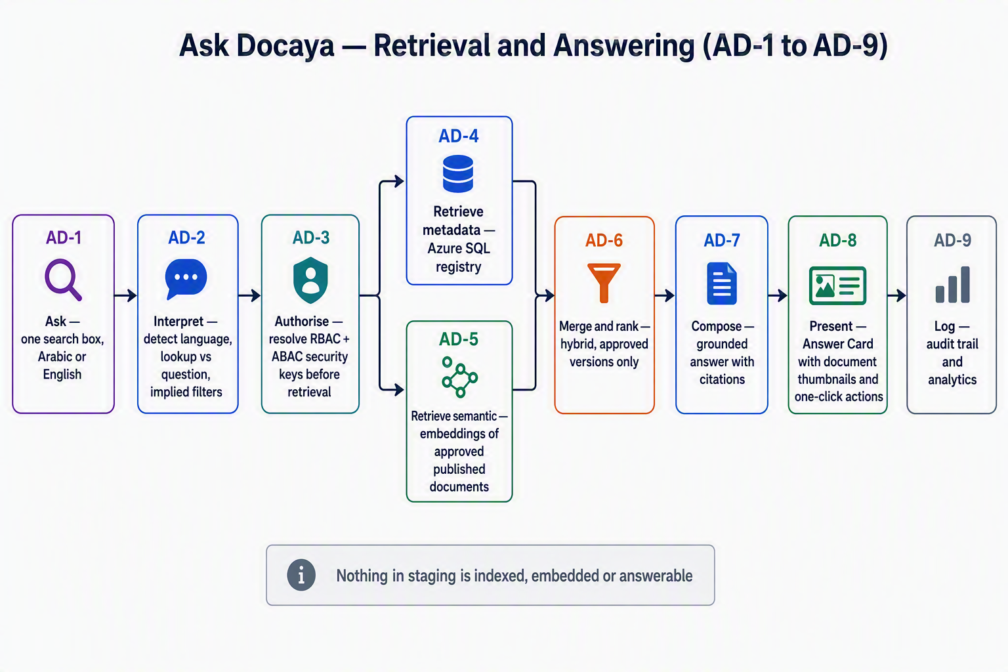
Figure 3 — Ask Docaya process flow AD-1 to AD-9: permission resolved before retrieval, parallel metadata and semantic retrieval over approved content only, hybrid ranking, a cited answer, and full audit logging.

6. Connected Solution Architecture
This architecture is the connected v1.3 view. It carries the staging-first lifecycle unchanged and adds the post-publication indexing and answering path introduced by Ask Docaya, which is physically separated from capture, registration and classification so that no unapproved content can reach it.

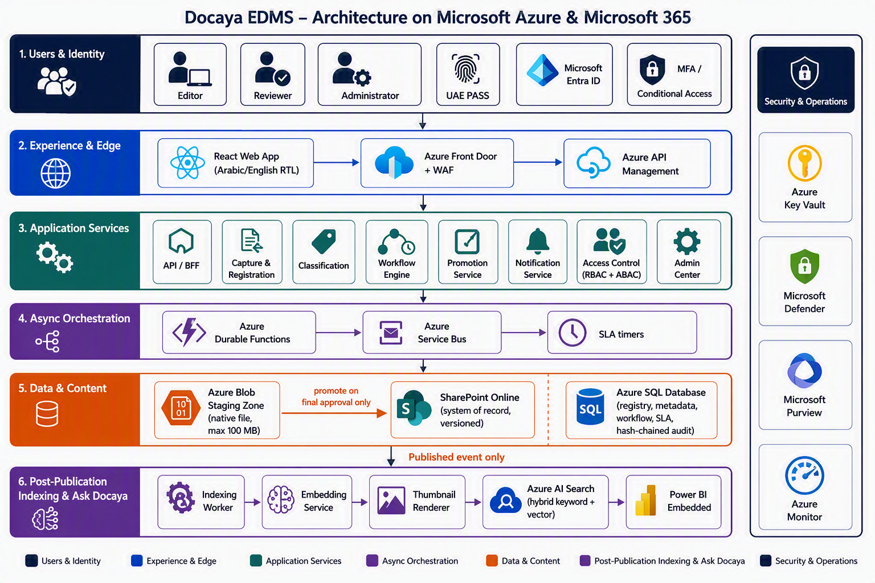
Figure 2 — Docaya solution architecture: identity and edge, application and orchestration services, staging-to-SharePoint content path, the Azure SQL registry and audit store, and the separately fed post-publication indexing and Ask Docaya zone.

6.1 Connected request and publication path
User  UAE PASS  → | Edge  WAF + APIM  → | API  RBAC + ABAC  → | Staging  Blob + SQL  → | Review  Durable + Bus  → | Publish  Graph service ID  → | Record  SharePoint  → | Index & Ask  Search + BI + answers

Authority boundary Docaya authenticates users through UAE PASS/Entra, evaluates RBAC+ABAC internally, and records the real user as actor. Microsoft Graph calls are executed by a least-privilege governed service identity. The indexing and answering zone is fed only by the Published event and inherits the same permission keys.

6.2 Identity, Access Control and Service-Identity Integration
Docaya separates who the user is from how data is moved. These are two distinct planes and they never mix. In the user plane, a person signs in through UAE PASS federated to Entra ID, and Docaya alone decides what that person may see and do. In the system plane, every read and write against Azure Blob Storage, Azure SQL, Azure AI Search and its vector store, SharePoint Online and Azure Key Vault is performed by Docaya's own system identity — a managed or workload identity with no password and no user token attached. The user's token stops at the Docaya API; it is never forwarded to any downstream store. This keeps permission management in one place, keeps back-end access least-privilege and uniform, and keeps every action attributable to the real person who requested it.
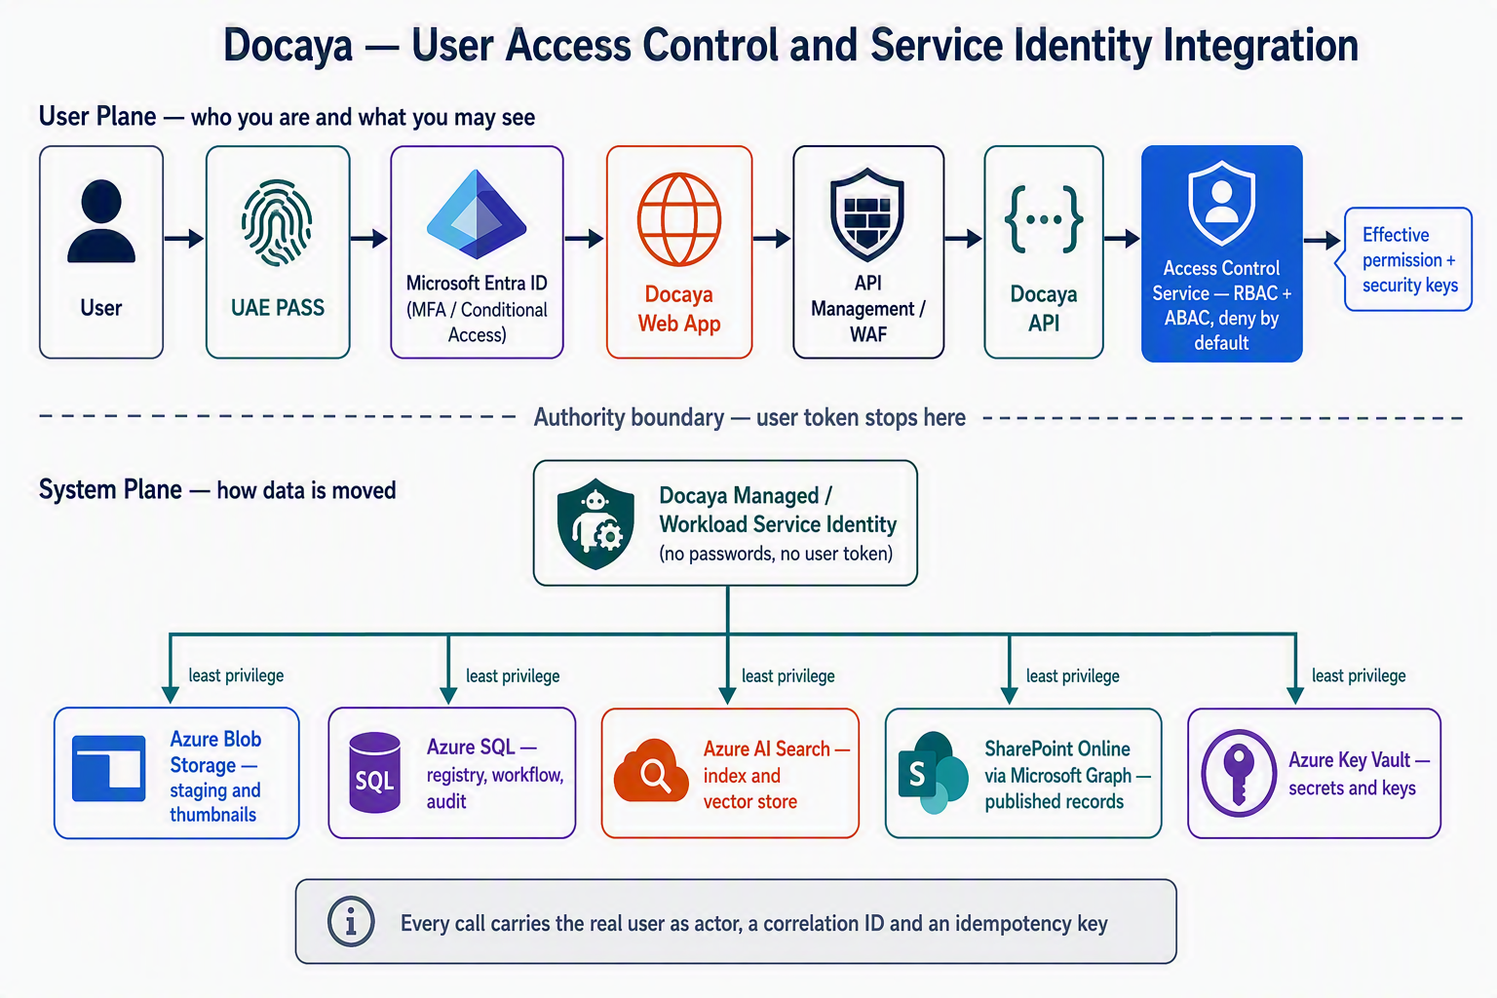
Figure 3 — Access control and service-identity integration: the user plane resolves identity and effective permission, the authority boundary stops the user token at the API, and a single least-privilege system identity performs every operation against Blob, Azure SQL, AI Search, SharePoint and Key Vault.

Process flow — sign-in to data access
Step | Stage | What happens | Identity in use
S-1 | Sign in | The user authenticates with UAE PASS, federated to Entra ID. MFA and Conditional Access are evaluated by Entra, not by Docaya. | User identity
S-2 | Token validation | The signed-in web app calls the Docaya API through the WAF and API Management, which validate the token, audience, issuer and rate limits. | User identity
S-3 | Access control | Docaya resolves the effective permission from RBAC roles plus ABAC attributes (department, sensitivity, clearance, document scope) and converts it into security keys for this request. Deny by default; the decision is logged. | User identity
S-4 | Authority boundary | The user token stops here. It is never forwarded to Blob, SQL, AI Search, SharePoint or any other resource, and it is never stored. | Boundary
S-5 | Token acquisition | The service requests a token for the target resource using its managed or workload identity. No client secret or password is held in configuration or code; any residual secret lives only in Key Vault. | System identity
S-6 | Data operation | The system identity performs the pull or push — read or write a staged file in Blob, query or update Azure SQL, query the AI Search index and vector store, or upload and read the published file in SharePoint through Microsoft Graph. | System identity
S-7 | Result trimming | Results are filtered against the security keys resolved at S-3 before anything is returned, so a broad system identity can never widen what a user sees. | Both planes
S-8 | Attribution and audit | The audit record names the real user as actor, the system identity as executor, the resource touched, the correlation ID and the outcome — so a shared executor never obscures accountability. | Both recorded

System identities and their least-privilege scope
Docaya does not use one omnipotent account. Each workload carries its own identity with only the permissions that workload needs, so a compromise or defect is contained. All identities are Entra-issued managed or workload identities; none uses a stored password.
Identity | Target resource | Granted permission | Used for
API service identity | Azure SQL | Data reader and writer on the application schema only; no DDL or server-level rights. | Registry, metadata, workflow state, review thread, SLA and audit writes.
API service identity | Azure Blob Storage | Data contributor on the staging and preview containers only, over a private endpoint. | Chunked upload, staged file read, thumbnail write and read.
Promotion worker identity | SharePoint Online via Microsoft Graph | Application permission scoped by Sites.Selected to the approved Docaya site collections and libraries — never tenant-wide. | Promotion of the approved native file, version creation and read-back of item ID, URL and version.
Indexing worker identity | Azure AI Search (index and vector store) | Index data contributor on the Docaya index only; the API holds query rights alone. | Building the Document Index Record after publication; write access is separated from query access.
API service identity | Azure AI Search (query) and the embedding model endpoint | Query only, plus invoke rights on the approved model deployment. | Ask Docaya hybrid retrieval and answer composition, always with the caller's security keys applied.
Workflow worker identity | Azure Service Bus | Send on publishing topics and receive on its own subscriptions only. | Review orchestration, SLA timers, promotion and notification commands.
All workload identities | Azure Key Vault | Get and list on the specific secrets or keys that workload requires. | Any residual third-party credential, signing key or connection material.
Analytics identity | Power BI and the reporting model over Azure SQL | Read on the reporting views only, with row-level security bound to the same department and sensitivity scope. | Embedded dashboards that show each viewer only what they may see in the application.

Governing rules The user token never leaves the Docaya API. No connection string, password or client secret is held outside Key Vault. Every workload has its own identity with least privilege, scoped to named containers, schemas, indexes and site collections. Authorization is always evaluated before the data call, and results are always trimmed after it. Every operation records the real user as actor and the system identity as executor. Access from a system identity is itself audited, reviewed periodically, and revocable without a code change.

6.3 Integration Patterns and Standards
Every integration — inside Docaya and out to Azure, Microsoft 365 and any future system — follows the same named patterns and open standards. Nothing is integrated ad hoc, so behaviour under failure, retry and change is predictable and reviewable.
Area | Pattern or standard | How it is applied in Docaya
Interface style | Contract-first REST over HTTPS, described in OpenAPI 3.x | The contract is written before the code, published from the contracts package, and used to generate both the web and server clients so drift cannot occur.
Versioning | URI major version with backward-compatible minor change | All endpoints sit under /api/v1. Additive change only within a version; a breaking change requires a new major version and an overlap period.
User authentication | OAuth 2.0 and OpenID Connect with PKCE | The single-page app uses the authorization code flow with PKCE; no implicit flow, no token in browser storage beyond the supported session model.
Service authentication | Managed or workload identity; OAuth 2.0 client credentials where an identity cannot be used | Secretless by default (Section 6.2). Tokens are cached in memory, refreshed before expiry and never written to logs.
Internal layering | Ports and adapters over clean architecture | Every external system is reached through an adapter behind a port, so SQL, Blob, Graph, Search and Power BI can be substituted or mocked without touching domain logic (Section 7.1).
Asynchronous work | Event-driven publish and subscribe over Service Bus, with a documented event schema | Long-running work — promotion, indexing, notification, SLA — is triggered by the domain events in Section 9.4 rather than by synchronous chaining.
Reliable publishing | Transactional outbox | State change and its event are written in one SQL transaction, then dispatched, so a document can never be approved without the promotion event being raised.
Delivery safety | At-least-once delivery with idempotent consumers | Every write carries an idempotency key, so a retried promotion or index update produces one result, never a duplicate SharePoint item.
Failure handling | Retry with exponential backoff and jitter, circuit breaker, timeout, dead-letter | Applied to every outbound call. Poison messages move to a dead-letter queue with an operator replay path; nothing is silently dropped.
Large file transfer | Chunked resumable upload sessions | Used for the 100 MB browser upload into Blob and for the Microsoft Graph upload session into SharePoint, with hash verification at both ends.
Traceability | W3C Trace Context correlation with OpenTelemetry | One correlation ID follows a request from the browser through the API, the queue, the worker and into the audit record, so any action can be reconstructed end to end.
Transport and network | TLS 1.2 or higher, private endpoints, gateway-only ingress | Data services are reached over private endpoints; the only public entry is Front Door, WAF and API Management; Graph egress is explicitly controlled.
Error semantics | Standard problem-detail responses | A consistent error shape with a correlation ID and no internal detail or stack trace exposed to the caller.
Data residency | In-region processing only | Every integration endpoint, including the search, embedding and answering services, resolves to the approved UAE Azure regions and Microsoft 365 tenant controls.

7. Application Architecture and VS Code Structure
Deployable package | Internal structure | Artifact
src/web | React/TypeScript/Fluent UI; feature folders M1–M16; i18n/RTL; generated API client. | Static bundle
src/api | Docaya.Api, Application, Domain, Infrastructure and Tests. | Container image
src/functions | Durable orchestrations, activities, Service Bus consumers, SLA/expiry/cleanup/search timers. | Function package
src/contracts | OpenAPI and event schemas; generated TypeScript/C# clients. | Versioned contract package
infra | Bicep modules and environment parameters. | IaC package

7.1 Clean Architecture Dependency Rules
- Domain depends on no Azure or Microsoft SDK.
- Application contains use cases and ports and depends only on Domain.
- Infrastructure implements SQL, Blob, Graph, Search, messaging and Power BI adapters.
- API composes dependencies and applies authentication, authorization, validation, correlation and safe error handling.
- Durable workflow is part of the Functions package, not a separate deployable top-level project.

8. Data Architecture
Store | Role | Content
Azure SQL | Authoritative structured store | Documents, metadata, workflow and stages, review thread, SLA calendar and events, ACL policy, notifications, retention and hash chain.
Blob staging | Transient native file store | Upload chunks, original file, scan status, basic source text and preview.
SharePoint Online | Published content system of record | Approved native file and native approved versions.
Azure AI Search | Rebuildable derived retrieval view | Document Index Record per approved version: published metadata, approved source-text passages with page and version reference, embedding vector, thumbnail reference and permission keys.
Blob preview store | Regenerable visual store | One document thumbnail per version, retained against its own version and served only through a permission-checked endpoint.
Power BI semantic model | Rebuildable reporting view | Operational and historical facts over Azure SQL.

8.1 Core Entities
Entity | Essential fields
Document | DocumentId, TrackingNumber, status, class, sensitivity, department, Standard, Department Tag, Publishing Scope, owner, expiry, staging and SharePoint references.
WorkflowInstance / Stage | Route version, stage number, role and assignee, decision, entered and acted timestamps, quorum.
ReviewThread | Action, comment, actor, stage, correction point, reassignment, extension and timestamp.
SlaEvent | Request type, calendar, original and current target, at-risk and overdue state, extension reason.
AuditEvent | Actor, action, object, request ID, source, outcome, prior hash and hash.
Retention / Hold | Policy trigger, duration, disposition, hold scope and release history.
Revision | Base approved version, rationale, request type (Urgent or Normal), target date, comparison reference, resulting version and new thumbnail reference.
DocumentIndexRecord | DocumentId, version, business metadata, technical properties, approved text passages, embedding reference, thumbnail reference, ACL keys and index build timestamp.

9. Integration and API Specification

9.1 SharePoint / Graph
- Managed/workload service identity with least-privilege application permission scoped to approved sites/libraries.
- Large files use Graph upload sessions; native format and hash are preserved.
- Docaya authorization precedes every Graph operation; the real user is captured in audit.
- Item/drive/site IDs, URL, version and hash confirmation return to Azure SQL.

9.2 Search Publication
- Upload-time extraction is limited to basic machine-readable/source text, file attributes, preview and thumbnail — no classification, recommendation or embedding.
- A Published event is the only trigger that upserts approved metadata, source text, embedding, thumbnail reference and permission keys into the live index.
- Supersession, access changes, disposition and hold events update or remove the index entry within the agreed cadence.
- Retrieval is hybrid — keyword plus vector — and always executed with the caller's security keys; answers are composed only from retrieved approved passages and carry citations.
- The index and embeddings are fully rebuildable from Azure SQL and SharePoint, and never hold the only copy of anything.

9.3 Representative APIs
Method | Path | Purpose
POST | /api/v1/documents | Capture and registry creation
POST | /api/v1/documents/{id}/chunks | Resumable upload
PATCH | /api/v1/documents/{id}/registration | User-entered registration fields
PUT | /api/v1/documents/{id}/classification | Manual classification
POST | /api/v1/documents/{id}/submit | Start review chain and SLA
POST | /api/v1/reviews/{stageId}/decision | Approve or return with comment
POST | /api/v1/requests/{id}/extension | Authorised SLA extension
POST | /api/v1/documents/{id}/revisions | Submit a New Revision (M14)
GET | /api/v1/documents/{id}/timeline | Unified history and version thread
GET | /api/v1/documents/{id}/versions/{v}/thumbnail | Permission-checked thumbnail
POST | /api/v1/search | Permission-trimmed Quick Search
POST | /api/v1/ask | Ask Docaya cited answer (approved content only)
GET | /api/v1/analytics/embed | Power BI embed configuration

9.4 Domain Events
Event
DocumentRegistered | Audit, notifications
DocumentSubmitted | Workflow, SLA, notifications
ReviewDecisionRecorded | Workflow, audit, analytics
SlaRiskChanged | Notification, analytics
FinalApprovalGranted | Promotion worker
DocumentPublished | Cleanup, indexing, notification, analytics
DocumentIndexed | Ask Docaya, audit, analytics
RevisionApproved | Promotion, thumbnail capture, index refresh, notification, audit
RetentionActionDue | Records and notification

10. Security, Compliance and Operations
Control | Design
Authentication | UAE PASS → Entra ID; OIDC + PKCE; MFA and Conditional Access.
Authorization | RBAC app roles + ABAC department/sensitivity/clearance and document scope; deny by default.
Workload identity | Separate managed identities; governed SharePoint service identity.
Network | Front Door/WAF/APIM; private endpoints/DNS for supported data services; controlled Graph egress.
Data protection | TLS, encryption at rest, Key Vault, malware/DLP and Purview controls.
Audit | Hash-chained SQL record with immutable export option and full user attribution.
Residency | Approved UAE Azure regions and Microsoft 365 tenant controls.
Observability | OpenTelemetry, Application Insights, Log Analytics, alerts and operational dashboards.

11. Non-Functional Requirements
Attribute | Target
Availability | 99.9% baseline, increased through selected tiers and zone redundancy.
Page load | p95 under 1.5 seconds at the agreed load.
Search | p95 under 400 ms at the agreed index and permission-filter complexity.
Ask Docaya answering | p95 under 3 seconds to first answer; 100% of statements cited; zero unauthorised disclosure; index freshness within the agreed cadence of publication.
Maximum file | 100 MB per file, one file per registration, resumable chunked upload.
Recovery | RPO of 5 minutes or better; RTO of 1 hour or better for the approved topology.
Accessibility | WCAG 2.2 AA; Arabic and English; RTL and keyboard access.
SLA engine | 12 and 30 working days by default; configurable calendar and warning window.
Auditability | 100% of lifecycle, access, configuration and security actions attributable.
Scale | Stateless horizontal API scale and queue or load-based worker scale; final sizing by performance test.

12. Packaging, Deployment and Environments
Artifact | Format
Web UI | Versioned static bundle
API/BFF | Immutable container image digest
Functions/workflow | Versioned function package
Contracts | OpenAPI and event schemas
Infrastructure | Bicep modules and non-secret parameters
Database | Versioned migration bundle
Configuration | Schemas, stages, routes, calendars, taxonomies and notification templates
Evidence | SBOM, checksums, scan/test reports, release manifest and runbooks

12.1 Deployment Sequence
- Validate tenant/subscription, regions, quotas and identities.
- Run Bicep build and what-if; approve the change set.
- Provision network, private connectivity, Key Vault, stores, messaging, observability and compute.
- Create managed identities and least-privilege role assignments.
- Configure UAE PASS/Entra federation and governed Graph service identity scope.
- Apply SQL migrations and seed approved configuration.
- Deploy API, Functions and Web artifacts by immutable version.
- Import APIM contract/policies and configure Front Door/WAF/custom domains.
- Run end-to-end smoke and security journeys, then progressively shift traffic.
- Publish the manifest and hand over runbooks and dashboards.

13. Testing and Acceptance
Layer | Required coverage
Unit | State machine, working-day SLA, routing, idempotency, hash chain and authorization policy.
Integration | SQL, Blob chunks, Graph upload, index publication, Service Bus and Power BI embed.
Contract | OpenAPI and event compatibility.
End-to-end | Capture, classify, three or four-stage review, return and resubmit, publish, index, then search and ask; Submit a New Revision through to the next version with a fresh thumbnail and refreshed index.
Retrieval quality | Bilingual extraction accuracy, hybrid ranking against a labelled question set, citation correctness, refusal when no approved source exists, and negative tests proving no unauthorised or unapproved content is retrievable.
Security | SSO, role matrix, service-identity scope, DLP and malware, and penetration testing.
Performance
Accessibility | WCAG AA, keyboard, Arabic and RTL.
Recovery | Promotion replay, dead-letter handling, SQL restore, index rebuild and regional recovery.

13.1 UAT Exit Criteria
- All Must requirements pass with evidence.
- No open Severity-1 or Severity-2 defects.
- No unapproved document appears in SharePoint, live search, an Ask Docaya answer or a thumbnail.
- Staged and published hashes match.
- Role and attribute tests pass for every persona, including the trimming applied to answers, result rows and previews.
- SLA dates, stage durations, extensions and analytics reconcile to test data.
- Every answer in the acceptance question set is grounded and cited to an approved version, and cross-language Arabic and English retrieval returns the same source document.
- All Critical POC workstreams (Section 14) have passed and their decisions are recorded.

14. Proof of Concept (POC) Plan
The purpose of the POC is to establish the right technical route before build commits, not to produce a demonstration. Each workstream answers a specific question that carries material technical, performance or compliance risk, produces measurable evidence, and closes with a recorded decision. Modules classified POC – Critical in Section 3 must complete and pass before the corresponding build stream starts; POC – Recommended items may run in parallel with early build; POC – Not required items proceed directly to build. The POC runs in a dedicated non-production subscription in the approved UAE region, using a representative sample of real Client documents in Arabic and English, and reuses the same identities, service identity scope and configuration model as production.

14.1 POC Priority by Module
Priority | Modules | Why it must be proven
Critical — first | M10 Ask Docaya, M6 Extraction & Index, M12 Access Control | Highest uncertainty and highest consequence: bilingual extraction quality, hybrid ranking, grounded citation and permission trimming applied to answers, results and thumbnails. A weakness here is a disclosure risk, not just a quality issue.
Critical | M11 Identity & SharePoint, M4 Promotion | UAE PASS federation with MFA and Conditional Access, and the governed service identity writing to SharePoint idempotently without format change, are external dependencies that gate every other stream.
Critical | M1 Capture, M2 Classification | Resumable 100 MB single-file upload, signature validation, hashing and reliable thumbnail generation across PDF, Office and image formats; and validation of the taxonomy against real documents.
Recommended | M3 Workflow & SLA, M7 Notifications, M14 A New Revision | Proven patterns, but the working-day calendar, stage timings, broadcast fan-out and version comparison should be validated at Client scale and against the Client's own calendar and department structure.
Recommended | M9 Records & Retention, M15 Analytics, M16 Audit | Retention and legal hold across Azure and SharePoint, Power BI row-level security matching application scope, and tamper-evident audit export for IA and PDPL assurance.
Not required | M5 Staging Lifecycle, M8 Correspondence, M13 Admin Center | Standard platform capability or configuration over the proven core pipeline; no novel technical risk, so these proceed straight to build.

14.2 POC Workstreams, Method and Success Criteria
Ref | Workstream | Question to answer and method | Success criteria | Duration · dependency
P1 | Identity & governed access  M11 · M12 | Can UAE PASS federate to Entra ID with MFA and Conditional Access, and can one governed service identity hold least-privilege read/write across the document estate? Stand up federation in the test tenant, define the application permission scope, and evaluate RBAC + ABAC effective permission at query time against a test role matrix. | Policy-compliant sign-in succeeds for every persona; no user token is ever used against SharePoint; every persona sees exactly the documents the matrix predicts, with zero false positives on deny cases. | 2 weeks · needs tenant and UAE PASS onboarding — start first
P2 | Capture, staging & thumbnails  M1 · M2 | Does resumable chunked upload of a single 100 MB file work reliably, and can a usable thumbnail be produced for every supported format? Upload a corpus spanning PDF, DOCX, XLSX, PPTX and images, including scanned and Arabic documents; force network interruption; validate by signature; compare hashes; render previews. Test the taxonomy — class, sensitivity, Standard, Department Tag, Publishing Scope — against real documents with business users. | 100% of interrupted uploads resume and complete; staged hash always matches source; a thumbnail or an agreed neutral fallback is produced for every format; business users can classify a sample set with no missing or ambiguous values. | 2 weeks · needs sample documents — can run parallel to P1
P3 | Promotion to SharePoint  M4 · M5 | Can the approved file be moved from staging into the correct library, unchanged, exactly once? Drive Microsoft Graph upload sessions under the service identity, inject failures mid-transfer, replay with the idempotency key, and confirm write-back of item ID, URL and version to Azure SQL. | Published hash equals staged hash with no format change; replay after any injected failure creates no duplicate item; registry always resolves to the correct SharePoint record and version. | 2 weeks · depends on P1 service identity scope
P4 | Bilingual extraction & indexing  M6 | Is extracted Arabic and English text good enough to answer from, and how fresh is the index after publication? Extract and chunk the corpus, score extraction against a manually verified sample, build the Document Index Record only on the Published event, and measure end-to-end indexing latency and full-rebuild time. | Agreed extraction accuracy threshold met in both languages, with a documented fallback for low-quality scans; no index entry exists for any staged item; index reflects a new publication within the agreed cadence and rebuilds within the agreed window. | 3 weeks · depends on P2 corpus and P3 publication
P5 | Ask Docaya retrieval & answering  M10 · M12 | Does hybrid retrieval find the right document and does the answer stay grounded and trimmed? Build a labelled question set of at least one hundred real business questions in Arabic and English with known correct sources; run AD-1 to AD-9; measure top-1 and top-5 accuracy, citation correctness, refusal behaviour where no approved source exists, cross-language retrieval and response latency; run negative tests as each persona against restricted documents. | Agreed top-5 accuracy threshold met in both languages; 100% of statements carry a valid citation; the system refuses rather than infers on every unanswerable question; zero unauthorised document, passage or thumbnail returned in any negative test; p95 under three seconds to first answer. | 3–4 weeks · depends on P1 and P4 — the pacing item
P6 | Review chain, SLA & revisions  M3 · M14 | Does the working-day engine compute correctly against the UAE calendar, and does a revision behave safely? Configure three- and four-stage chains, run approve, return, resubmit and extension paths across weekends and public holidays, and submit a New Revision against a published document with comparison and fresh thumbnail. | Targets, at-risk and overdue flags match manual calculation in every case; original target is never overwritten on extension; stage durations attribute delay to the right stage; the prior approved version and its thumbnail remain intact and retrievable. | 2 weeks · needs the confirmed calendar (Q4) — can run parallel
P7 | Notification reach  M7 | Can a department-wide publication broadcast and a first-login reading list be delivered without alert fatigue? Fan out a publication to a representative department across in-app, email and Teams, and trigger the onboarding list for a new test user. | Every entitled recipient receives exactly one alert; no recipient outside scope is notified; quiet hours and batching behave as configured; the reading list reflects the user's department and permissions. | 1–2 weeks · depends on P3
P8 | Retention, analytics & audit evidence  M9 · M15 · M16 | Can retention, hold and residency be enforced across Azure and SharePoint, and does reporting honour the same scope? Apply a retention schedule and legal hold, attempt deletion, embed Power BI with row-level security, and export the hash-chained audit for a document and a date range. | Hold blocks deletion and is fully audited; no data or processing leaves the approved UAE region; dashboards show only what the viewer may see; audit export reconciles to the workflow record and chain verification fails on any tampering. | 2 weeks · depends on P3 and P6 · needs Q6 licensing

14.3 POC Exit Criteria and Decisions Unlocked
Each workstream closes with a short evidence pack — configuration used, test data, measured results and any deviation — and a recorded decision. The POC is complete when every Critical workstream has passed, every Recommended workstream has either passed or produced an accepted mitigation, and the decisions below are closed. Where a threshold is not met, the fallback route stated against the decision is adopted and the design is amended before build rather than during it.
From | Decision to be closed | Fallback if the threshold is not met
P1 | Final Graph application-permission scope and the confirmed RBAC + ABAC attribute set (closes Q5). | Narrow the service identity to a defined site collection set and phase the remaining estate after a security review.
P2 | Staging location — Azure Blob or a SharePoint staging area (closes Q1) — and the confirmed taxonomy and library map (closes Q2). | Retain Azure Blob staging as the production standard; suppress thumbnails for any format that cannot be rendered reliably and use the neutral document-type icon.
P3 | Confirmation that promotion is idempotent and format-preserving at Client file sizes. | Introduce a reconciliation job that verifies hash and version after every promotion and quarantines mismatches for operator replay.
P4 · P5 | Whether Ask (AI Search) enters V1 scope or is deferred, and the accepted accuracy, latency and index-freshness thresholds. | Ship Quick Search and Browse in V1 with metadata and source-text matching only, and defer AI answering to V2 once extraction quality is remediated. Ask Docaya remains the single entry point either way.
P6 | Default stage count, department variants and correction-point rules (closes Q3); working-day calendar and at-risk window (closes Q4). | Adopt a single four-stage chain organisation-wide for V1 and introduce departmental variants after go-live through the Admin Center.
P7 | Default channel mix, batching windows and broadcast scope per Publishing Scope value. | Limit the publication broadcast to in-app and a daily digest email, with Teams delivery enabled per department after review.
P8 | Power BI capacity and dashboard layouts (closes Q6); retention schedule, hold policy and the e-signature requirement (closes Q7). | Deliver the standard report library from the application reporting layer in V1 and add embedded Power BI in V2 once capacity is approved.

POC gate Build of a Critical module does not start until its workstream has passed. The indicative POC window is eight to ten weeks end to end, with P1 and P2 starting together, P5 as the pacing item, and a single consolidated findings review at the end that updates this specification before the baseline is frozen.

15. Roadmap, Decisions and Open Items
Phase | Scope
MVP | M1–M5, M11–M12 and core audit: sign-in, staging-first lifecycle and native publication.
V1 | M7, M8, M10, M13–M14: notifications, correspondence, navigation/search, configurable chain/SLA and change requests.
V2 | M9, M15–M16: retention/holds, embedded analytics and extended audit/compliance.

15.1 Accepted Decisions
ID | Decision
D1 | SharePoint Online is published content SoR.
D2 | Manual classification and final approval precede native-file promotion.
D3 | UAE PASS federates to Entra ID.
D4 | SharePoint content operations use a governed service identity.
D5 | Azure SQL is authoritative for registry, metadata, workflow, SLA and audit.
D6 | No AI at capture, registration or classification. Embeddings and AI answering apply to approved, published content only, always permission-trimmed and cited (Ask Docaya, M10).
D7 | Review chain is configurable at 3–4 stages with threaded correction/resubmission.
D8 | Urgent/Normal targets default to 12/30 working days and preserve original targets on extension.

15.2 Open Items Before Baseline Freeze
ID | Item
Q1 | Confirm Azure Blob staging as production standard or approve SharePoint staging after POC.
Q2 | Confirm document classes, handling markings, Standard taxonomy and library map.
Q3 | Confirm stage variants, parallel/quorum and correction-point rules.
Q4 | Confirm working-day calendar and at-risk warning window.
Q5 | Approve Graph application permissions and site/library scope.
Q6 | Approve Power BI capacity/licensing and dashboard layouts.
Q7 | Confirm e-signature requirement and provider.

Build-baseline endorsement Approval of this consolidated v1.3 document supersedes v1.2 and v1.1 and authorises detailed design and build against the connected functional and technical baseline, subject to the Critical proof-of-concept workstreams in Section 14 passing before the corresponding build streams commit.

— End of Document —

